Question -1 Write a function to calculate LCM of two numbers. (TSRS)

Ans.

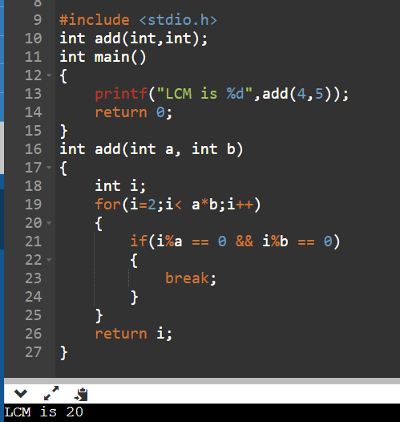

Question – 2 Write a function to calculate HCF of two numbers. (TSRS)

Ans.

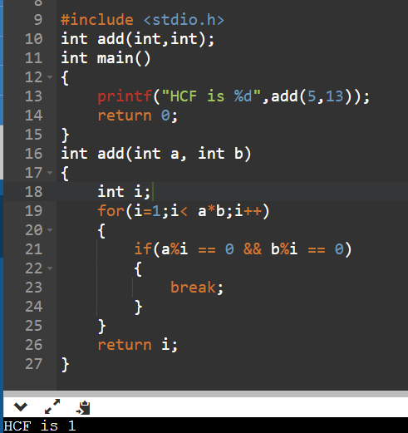

Question – 3 Write a function to check whether a given number is Prime or not. (TSRS)

Ans.

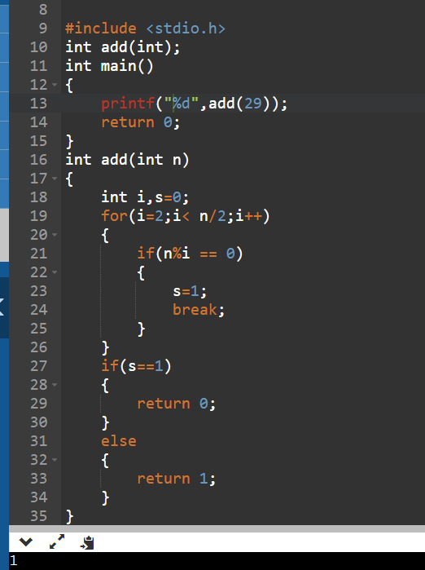

Question – 4 Write a function to find the next prime number of a given number. (TSRS)

Ans.

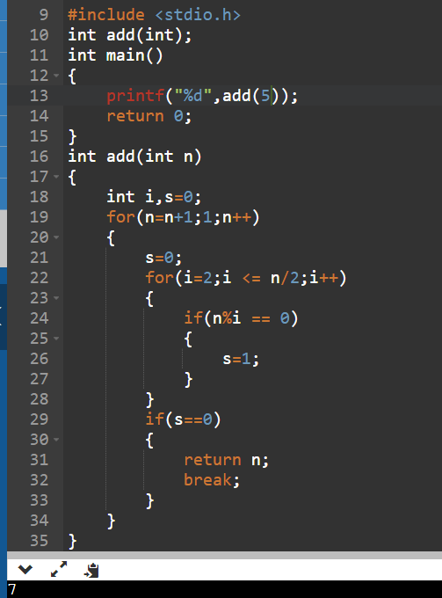

Question – 5 Write a function to print first N prime numbers (TSRN)

Ans.

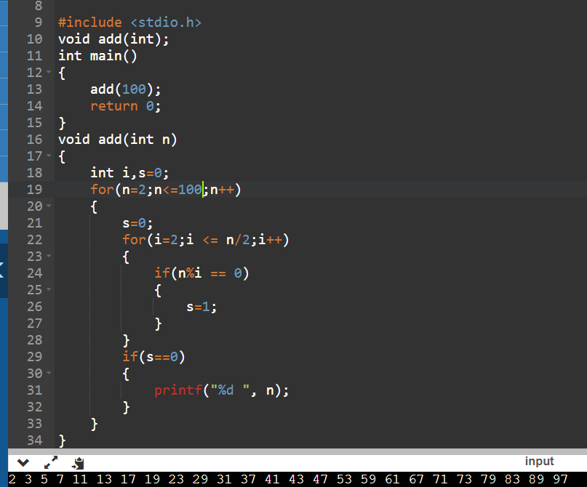

Question – 6 Write a function to print all Prime numbers between two given numbers. (TSRN)

Ans.

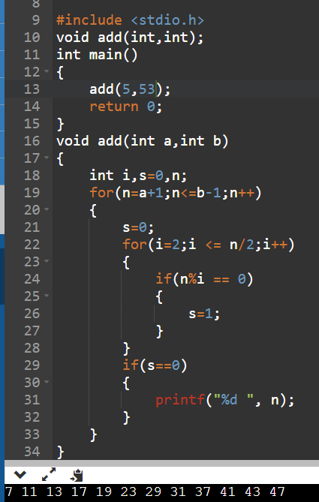

Question – 7 Write a function to print first N terms of Fibonacci series (TSRN)

Ans.

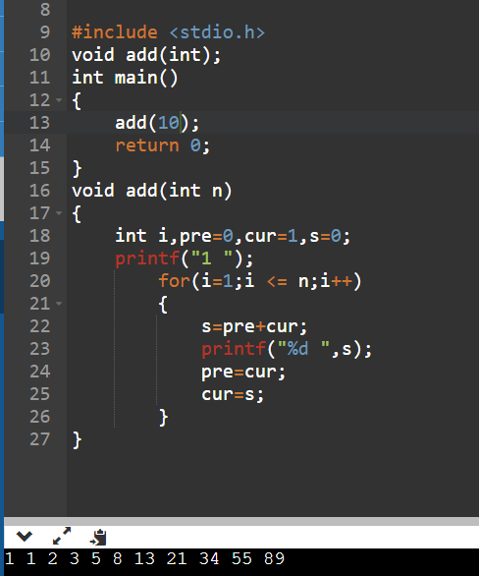

Question – 8 Write a function to print PASCAL Triangle. (TSRN)

Ans.

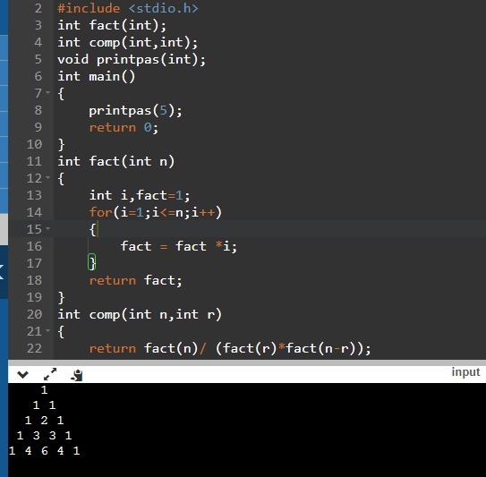

Question – 9 Write a program in C to find the square of any number using the function.

Ans

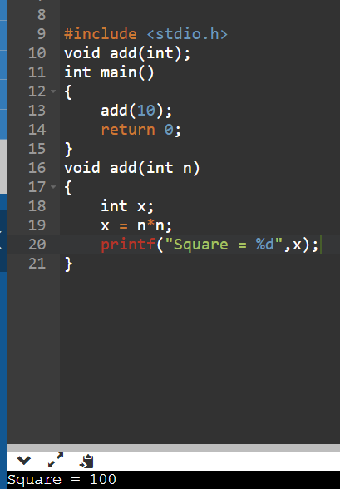

Question – 10 Write a program in C to find the sum of the series 1! /1+2!/2+3!/3+4!/4+5!/5 using the

Function.

Ans.

